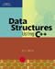 COSC 2320
Name: _________________ Terminal #__

Programming Assignment 2 C++:
(100 points.)
(Due date found in the COSC 2320 BB Calendar!)
The programming assignment is to be turned in as a hardcopy to include the source code & screenshots of the input/output AND ziped in BB Assignment PROGRAMMING ASSIGNMENT 2 as “Programming Assignment 2.zip” in the first ten minutes of the due date class.
A data file will be given to you in class for Acceptance Testing.
Assume the name “Programming Assignment 2 Data.txt”.

The hardcopy must contain the following statement and must be signed by the student.

I the undersigned declare that the project material, which I now submit, is my own work. Any assistance received by way of borrowing from the work of others has been cited and acknowledged within the work. I make this declaration in the knowledge that a breach of the rules pertaining to project submission may carry serious consequences.

Signature

___________________

QUEUE - Linked Implementation - Ticket System Application
ProgrammingAssignment2 APPLICATION
OOA, OOD, and OO Implement in C++:

XY Airlines (XYA) is considering redesigning its ticket counters for airline passengers. The company would like to have two separate waiting lines: one for regular customers and one for frequent flyers. Assuming there is only one ticket agent available to serve all passengers, the company would like to determine the average waiting time for both types of passengers using various strategies for taking passengers from the waiting lines (see figure below). A “democratic” strategy for serving passengers would be to take turns serving passengers from both lines (that is, one frequent flyer, one regular passenger, one frequent flyer, and so on). Another “democratic” strategy would be to serve the passenger who has been waiting in line the longest, but this would be the same as having a single queue. (Why?) An “elitist” strategy would be to serve any frequent flyer waiting in line before serving the regular passengers.

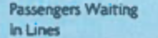
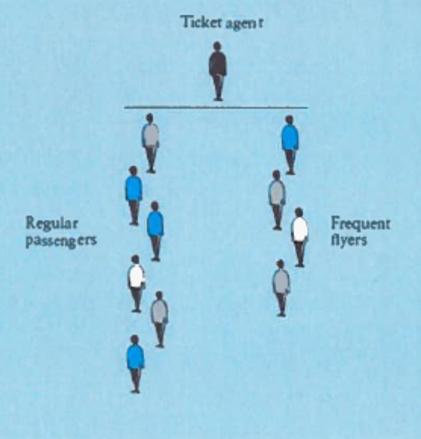

Running a computer simulation is a good way to investigate the effect of different serving strategies. To run a computer simulation, we must keep track of the current time by maintaining a clock that is set to an initial time of zero. This clock will increase by one time unit until the simulation is finished. During each time interval, one or more of the following events may occur.
1. A new frequent flyer passenger arrives in line.
2. A new regular passenger arrives in line.
3. The ticket agent finishes serving a passenger and begins to serve a passenger from the frequent flyer line.
4. The ticket agent finishes serving a passenger and begins to serve a passenger from the regular passenger line.
5. The ticket agent is idle because there are no passengers in either line to serve.

The purpose of running the simulation is to determine statistics about the waiting times for frequent flyers and for regular passengers. In addition to the priority given to frequent flyers, the waiting times depend on the arrival rate of each type of passenger (number of passengers arriving per minute) and the time required to serve a passenger. There are different arrival rates for each kind of passenger. In addition to statistics on waiting times, we can display a minute- by- minute trace of events occur-ring during each minute of the simulation. We can simulate different serving strategies by introducing a simulation variable frequent_ flyer_ max, which must be a positive integer. This will represent the number of consecutive frequent flyer passengers served between regular passengers. When frequent_ flyer_ max is 1, every other passenger served will be a regular passenger (the “democratic” strategy). When frequent_flyer_max is 2, every third passenger served will be a regular passenger. When frequent_ flyer_ max is a very large number, any frequent flyer passenger will be served before a regular passenger (the “elitist” strategy).

Assume that the “Programming Assignment 2 Data.txt” will contain the following (in RED are some samples):
Expected number of frequent flyer arrivals per hour: 15
Expected number of regular passenger arrivals per hour: 30
Enter the maximum number of frequent flyers served between regular passengers 5
Enter the maximum service time in minutes 4
Enter the total simulation time in minutes 10
Display minute-by-minute trace of simulation (Y or N) Y

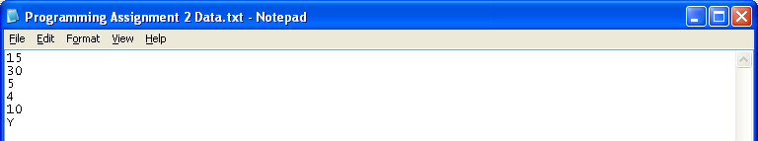

And a sample output could look like this:

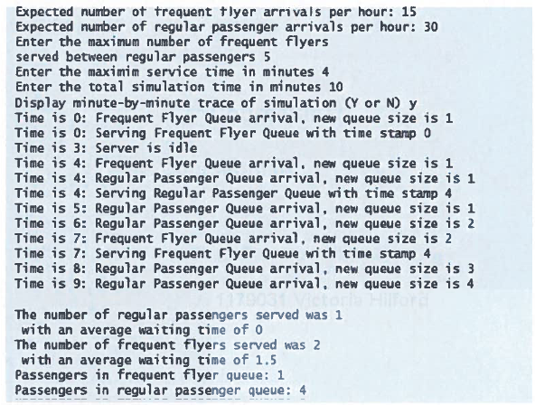

Create a ProgrammingAssignment2.cpp that contains the main method.

You cannot use any DATA STRUCTURES STL classes! Use linked Nodes.
One class per .cpp file! Must use MVC Design Pattern.

Each .cpp file must have these 4 lines of comments (you will lose 5 points if not):
// COSC 2320 Spring 2014
// Name:
// Programming Assignment 2
// This is my own work; I will not post

http://cristobal.baray.com/indiana/projects/mvc.html

MVC Introduction
The main idea behind design patterns is to extract the high level interactions between objects and reuse their behaviors from application to application. They were inspired by an architect, Christopher Alexander, discussing the way that architectural design has patterns of its own:
Each pattern describes a problem which occurs over and over again in our environment, and then describes the core of the solution to that problem, in such a way that you can use this solution a million times over, without ever doing it the same way twice.
A Timeless Way of Building
In theory this sounds great, but I've found in practice it takes some getting used to. Admittedly, it might take longer for me cause I'm a (reforming?) guerrilla programmer (the error in my ways has caught up with me and I'm taking steps towards programming for people - not computers). Sure, I've found that the design patterns are useful, but their advantage is not only in creating re-usable, easy to understand code - but, more importantly in helping me clarify the way that I think about programs. I find this second advantage much more substantial.
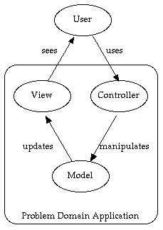
Writing code is usually the easy part - the hard part is figuring out exactly what code to write. Time spent carefully thinking about the code to write will save enormous amounts of time and effort when it comes to actually writing the code. Still, many people don't always work that way - myself included. Design patterns are helping me shape the way I parse a problem, which leads to helping me break up the problem into objects and modules. The Model View Controller pattern has probably changed my style and efficiency the most. It has lead to new ways of writing entire applications, constantly improving my applications in usability. Yet, while I was learning about the pattern, I was surprised at how hard it was to find information about it (some of the more useful bits of info I found are included in my references page - though Head First has become my favorite learning tool).
So, I decided to add a couple of pages about the pattern myself. I want to share some info about the pattern that I've found so useful but seems to get so little press. And I figured it would also clarify it even more in my own head. One little disclaimer - you might notice differences between what I present and what others present. The differences are representative of our styles I suppose - because I've made adjustments along the way and have changed things. I've tried to mention these areas when they pop up.
The MVC pattern is surprisingly simple, yet incredibly useful. Essentially, the pattern forces one to think of the application in terms of these three modules -
- Model(s) Class(es): The core of the application. This maintains the state and data that the application represents. When significant changes occur in the model, it updates all of its views
- Controller(s) Class(es): The user interface presented to the user to manipulate the application.
- Typically the UCs become methods in the Controller for that User (Actor).
- View(s) Class(es): The user interface which displays information about the model to the user. Any object that needs information about the model needs to be a registered view with the model.

1. OOA/OOD
You need to do TEXTUAL ANALYSIS ON THE REQUIREMENTS all using Microsoft Word AND TURN THAT IN TOGETHER WITH YOUR UML MODELS! See the two WORD documents attached to the Programming Assignment 2 OOA/OOD (MUST use WORD; MUST use the MVC Design Pattern).
(WITHOUT OOA/OOD YOU WILL LOSE 20 POINTS!)

2. Use C++ to OO Implement it (Visual Studio 2010 ONLY).
PLEASE NOTE THE DUE DATE!

A data file will be provided to you at the Acceptance Testing phase. The name that you are required to use is “Programming Assignment 2 Data.txt”.

DO NOT TURN IN THE PAGES in YELLOW, only the first PAGE.

